Stevens Institute of Technology
Department of Electrical and Computer Engineering

CpE 646 Pattern Recognition and Classification

Homework 3

- Save “hw3.mat” in your Matlab working directory.
- In Matlab, type “load hw3.mat”
- Then type “who”, you will find three matrices named “hw3_1”, “hw3_2_1” and “hw3_2_2”.
- Each of these matrices has a size of 2×100, i.e. 2 rows and 100 columns. Each column is a 2-D observation vector.

Problem 1: The sample vectors in “hw3_1” are drawn from a Gaussian Mixture Model (GMM) with two mixtures, which can be expressed as
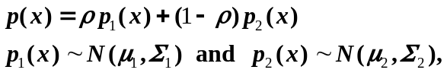

where x, µ₁, µ₂ are 2×1 vectors, and Σ₁, Σ₂ are 2×2 matrices, and ρ is the mixing parameter.

Use Expectation-Maximization (EM) algorithm to estimate the parameters µ₁, µ_{2,} Σ₁, Σ₂ and ρ.

Hint: Let the initial ρ₀=0.5, and assume the first 50 samples are from p₁(x) and the next 50 samples are from p₂(x). Use Maximum Likelihood method (CPE646-4, page 19) to estimate the initial µ₁, µ_{2,} Σ₁, Σ₂

Problem 2: The sample vectors in “hw3_2_1” are from class ω₁ and sample vectors in “hw3_2_2” are from class ω₂
- Use Parzen window method to estimate the class conditional density functions p(x|ω₁) and p(x|ω₂) for every x in {-4:0.1:8, -4:0.1:8}; use “mesh” function in Matlab to plot the results; and then classify x=[1,-2]^{t} based on the estimation. Let h₁=2.
- Construct a Probabilistic Neural Network (PNN); and classify x=[1,-2]^{t}. Let σ=0.2.

